Site for the Kuaotunu Library Identified
The Library Committee is delighted to announce that the Kuaotunu Library is working towards having its own new premises at the domain, with the generous assistance of the Domain Board.
The proposal being worked upon is for the other half of the toilet block (currently designated as a changing shed and storage facility, but very under-utilised) to be converted into premises for the library.
The existing benches and clothes pegs in the changing shed would be incorporated into the men's and women's toilets. The existing two doors on the changing shed side would be replaced by windows, french doors would be installed in the middle, and a lean-to and a wooden deck would be added at the front. A new storage shed would be erected at the back.
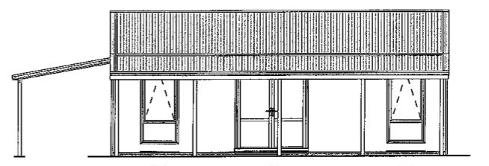
The Library Committee thinks this is a brilliant idea, and is very grateful to TCDC for suggesting it, and to the Domain Board for supporting it.
Adding a library to the domain, which already contains a sports field, tennis courts and BBQ (and is right next door to the Food Forest), would reinforce the domain as a great family-friendly area. What do you think? Let us know.

